**How to render images from Revit to Autodesk 360 and bring them back into Revit- By Adam Barnett and Dave Paz**

1. Go to [http://www.autodesk.com/education/student-software#](http://www.autodesk.com/education/student-software) and create an account (it’s free)
2. Download one of the free programs (at home, not at school) (ex. Revit) which will grant you unlimited credits on your Autodesk account so you can have unlimited renders
3. Open your Revit file and select the view you wish to render.
4. 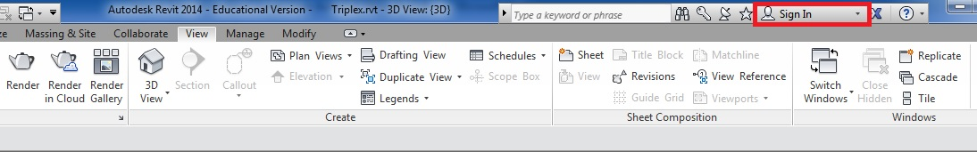Go to upper right of the toolbar and select “Sign In”. This will bring you to a log in screen for your Autodesk 360 account.

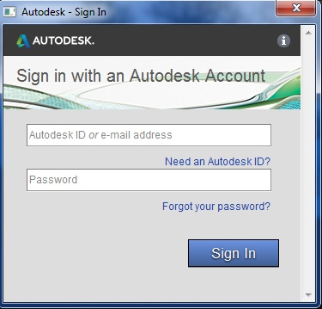

Now, select the “View” toolbar and select “Render in Cloud”. 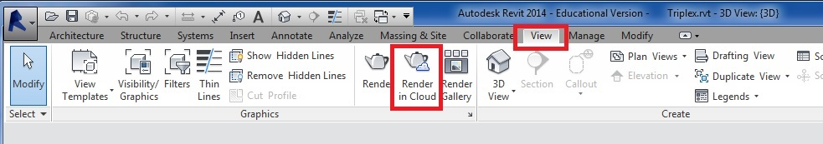 This will bring up a notice. Simply click continue and it will bring up another box that says on the top “Render in Cloud, Autodesk 360”.

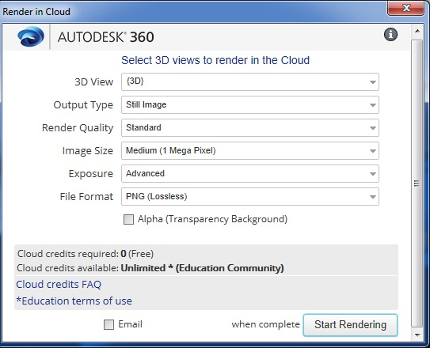

This is where you can select settings for your render, like if you want it to be a still image or interactive panorama (which is super cool!) You can also select the Render Quality of the render, etc.

When you are done with choosing your settings for the render, you can check off the box at the bottom that says “email (insert email address) when complete” which is probably a good idea since these renders take a long time to complete. Then click “Start Rendering” and you’re good to go!

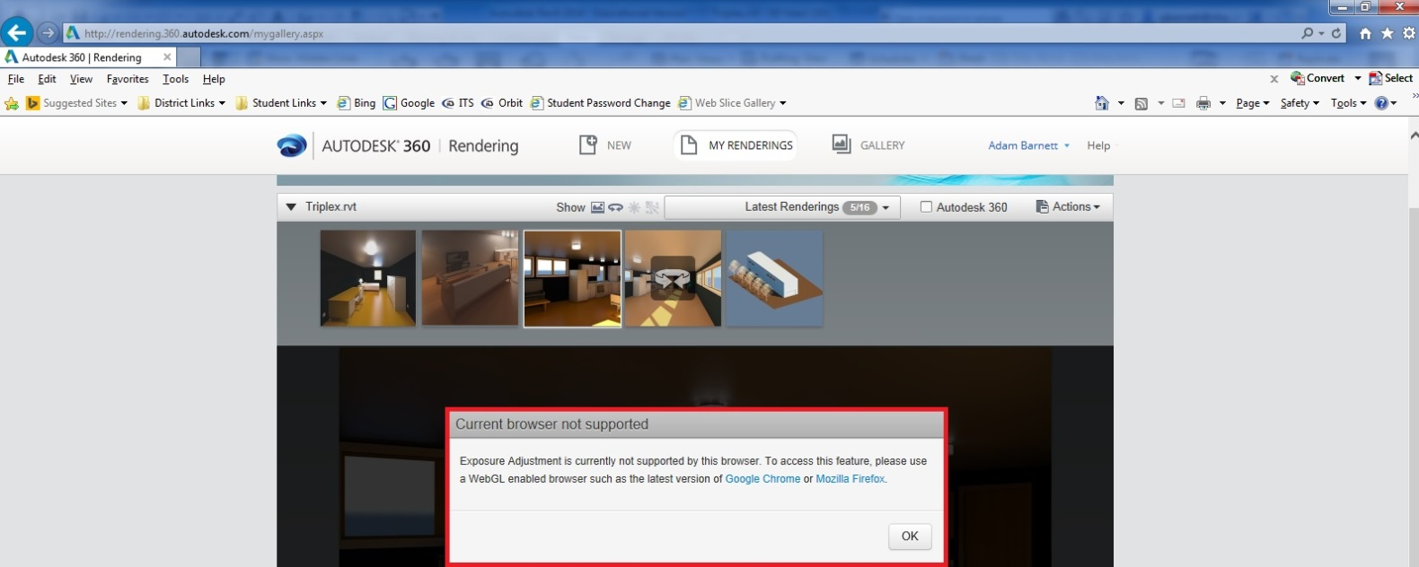Once your rendering is complete, if you don’t like the lighting, shadows or any details like that, you can select the render image, than select the box with the downwards arrow (bottom right of image) and select “Adjust Exposure”. **(*NOTE\*** you cannot adjust the exposure for a panoramic view. ALSO, you can only adjust the exposure in Google Chrome and Mozilla Firefox)

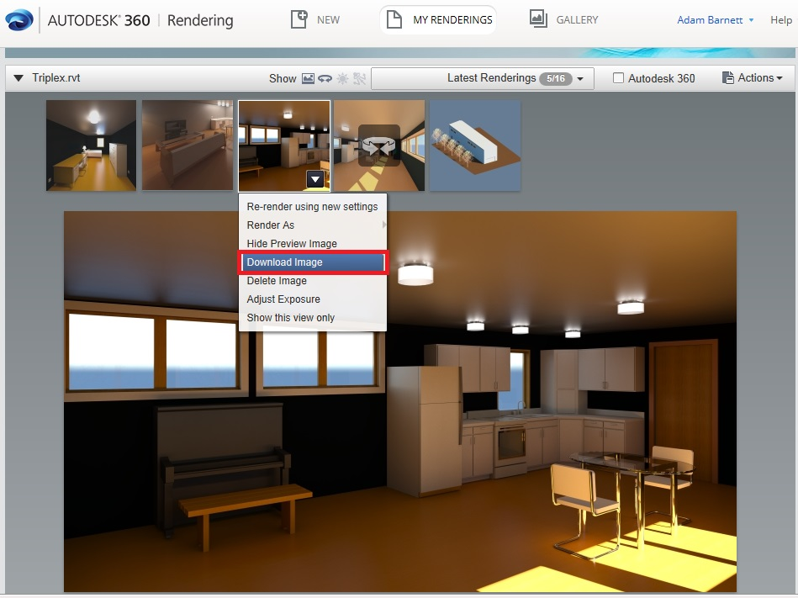Now that the render is done and it looks great, now you have to bring it back into Revit. To do so, select the render image, than select the box with the downwards arrow (bottom right of image) and select “Download Image”.

Once you select “Download Image”, a pop-up will appear on the bottom of the page. Select “Save- Save As” and Save the image as JPEG in your folder.

Now, go back to your Revit screen and select “Insert- Image”

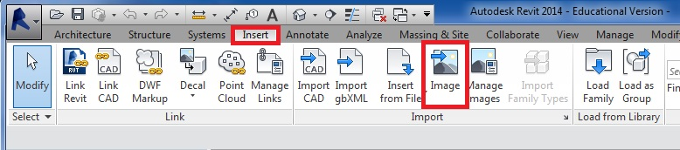

Find your JPEG file and select it and put it on whatever sheet you want.